Final Project Milestone Four

Pilot Plan

Michael Surdek
Southern New Hampshire University
DAT 640: Predictive Analytics
Professor Tom Woolman
February 20, 2022
Predictive Algorithm Recommendation
Rather than a single predictive model, The Insurance Company should algorithmically develop an ensemble of models whose knowledge can be combined to more accurately identify prospects that already have caravan insurance. Both random forests and boosting are ensemble learning approaches that can be applied to basic modelling techniques including regression and decision trees. A simple model, known as a weak learner, can quickly become a strong model through ensemble learning.
A random forest builds a certain number of independent models by randomly sampling observations and variables to be considered. The prediction that comes from the majority of the models, or the numerical average, is the prediction of the random forest. Boosting also builds multiple models, but they are not independent. “The basic distinguishing characteristic of the boosting approach…is that after building one model any observations that are incorrectly classiﬁed by that model are boosted.” (Willaims, 2011) The boosting process begins with equal weighting across observations, and the weights are adjusted based on the whether or not the prediction from each successive model is correct. “Subsequent trees help us to classify observations that are not well classified by the previous trees. Predictions of the final ensemble model is therefore the weighted sum of the predictions made by the previous tree models.” (Singh, 2018) In a boosting approach, not only are the observations weighted within the trees, but the trees are weighted in the final model based on their individual accuracy.
The caret package in R provides the gbm method for training a gradient boosting machine model. Caret also provides many arguments and controls that can be used to tune the parameters and refine the model. Sampling preferences, such as cross validation, are passed into the train control. Tree building options, such as the number of trees, the maximum depth of the tree, and the minimum number of observations of an eligible node, are passed into the tune grid.
Gradient Boosting Machine
The first step towards building a gradient boosting machine in R is loading the required packages and the insurance data set. The data file is read from my github profile for reproducibiliy purposes. The only transformations are simply assigning the 86 column names and converting the target variable, CARAVAN, to a factor with 2 levels, which is necessary for a binary classification model.
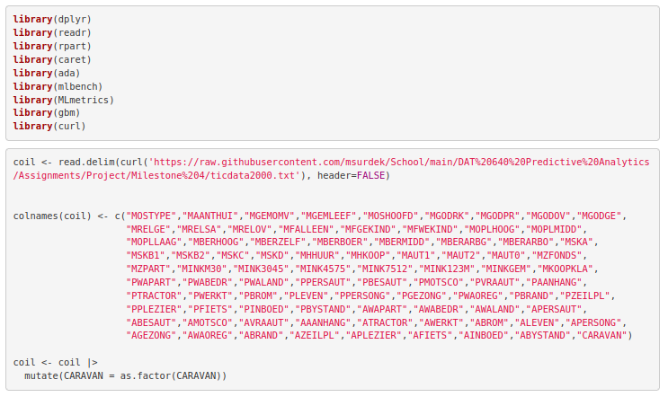
The data set is now prepared to be fed into the training function for the gbm model. First, the control and tuning options are stored as variables that will be passed to the training function. The control will use 5-fold cross validation. The algorithm will generate 1000 trees with a maximum depth of 30 nodes and a minimum number of observations in a node of only 1. The sampling seed is also set so that the same samples will be generated every time. Additionally, within the training function, the gbm method is specified and the distribution of the target variable is bernoulli, which is used for logistic regression of a binary outcome.
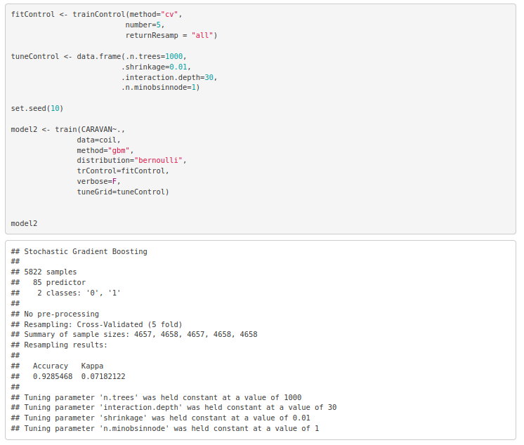
The model is now encoded as an object and some further information can be pulled from its elements. A summary of the model shows the variables with the largest relative influence on the target variable, CARAVAN. There are 6 variables with a relative influence greater than 2.5. These are, in descending order, customer subtype, car policy contribution, fire policy contribution, third party insurance contribution, protestant, and no religion.

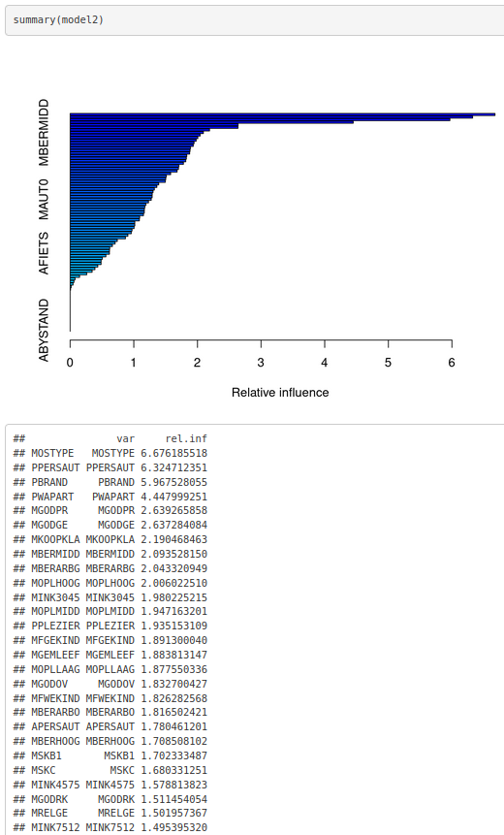
Finally, the confusion matrix of the observed and predicted values shows the errorr rate of the model and whether those errors are false positives or false negatives.
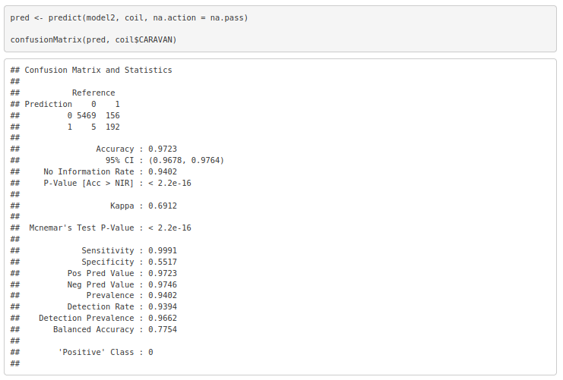
Of the 5473 observations where the customer did not already hold caravan insurance, only 5 were predicted as such. On the other hand, 192 of the 348 observations where the customer did already hold caravan insurance were predicted correctly. The overall accuracy rate of the model is 97.23%. If The Insurance Company used this model to advise their marketing strategy, they would successfully eliminate 55% of current caravan policy holders, at the cost of missing less than one in a thousand potential prospects.
References:

Singh, . 2018. Understanding Gradient Boosting Machines. Towards Data Science. Retrieved from https://towardsdatascience.com/understanding-gradient-boosting-machines- 9be756fe76ab

Williams, Graham. 2011. Data Mining with Rattle and R : The Art of Excavating Data for Knowledge Discovery. Springer New York. Retrieved from http://ebookcentral.proquest.com/lib/snhu- ebooks/detail.action?docID=770229

